**Aim:** Create a simple cloud software application for Students Attendance System using any Cloud Service Provider to demonstrate SaaS include the necessary fields such as name of the students, course, present , Absent, course attendance,OD request, grade, attendance percentage, etc.

**Step 1:** Create an application ‘Students Attendance System’ and create form ‘attendence’.

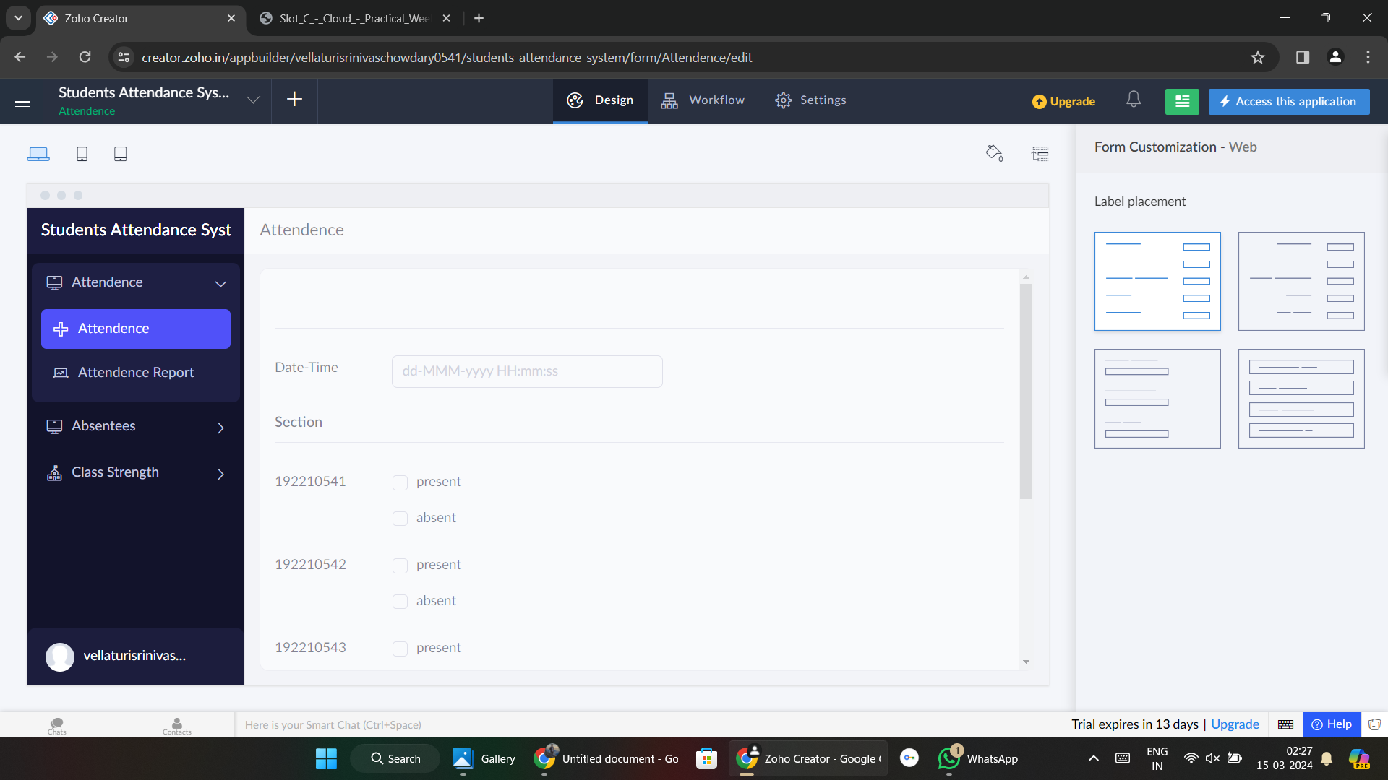

**Step 2:** Create form ‘absentees’ and add details.

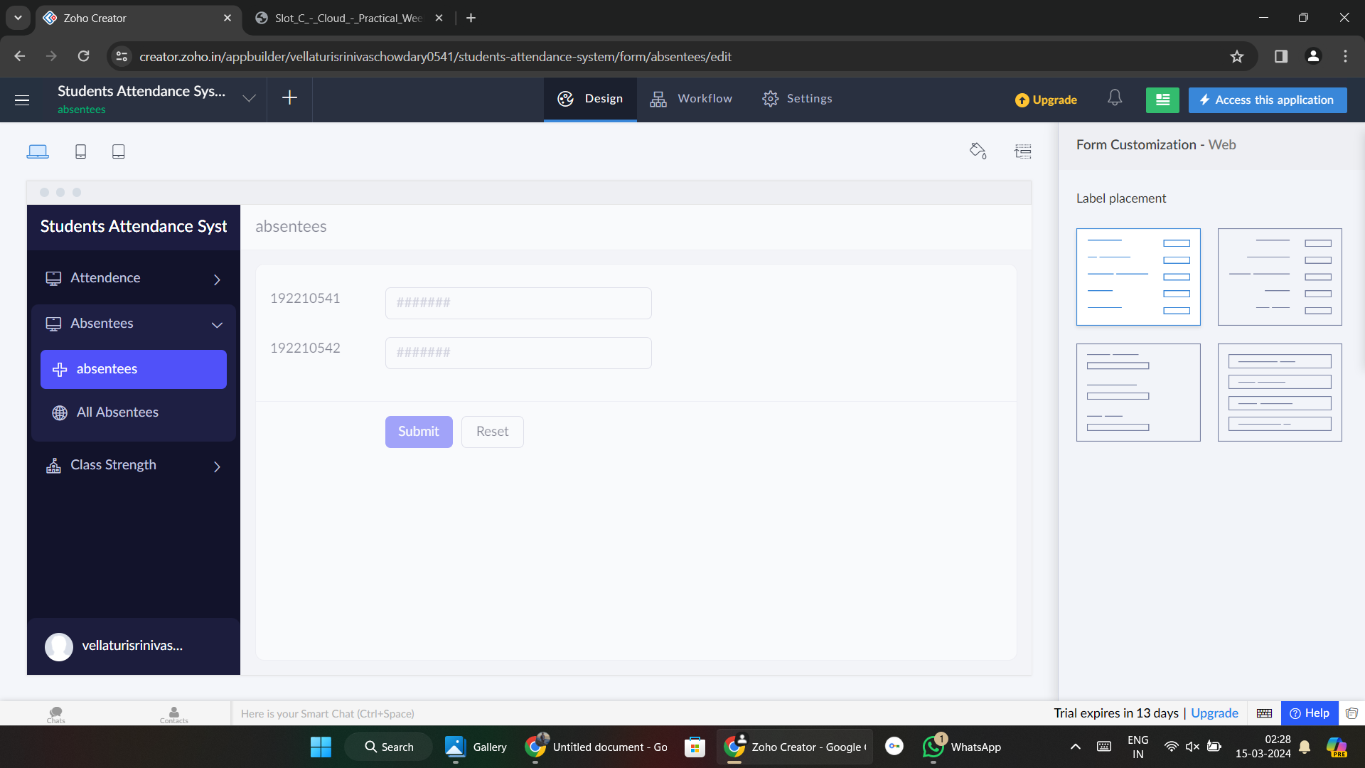

**Step 3:** Create form ‘class strength’ and add details.

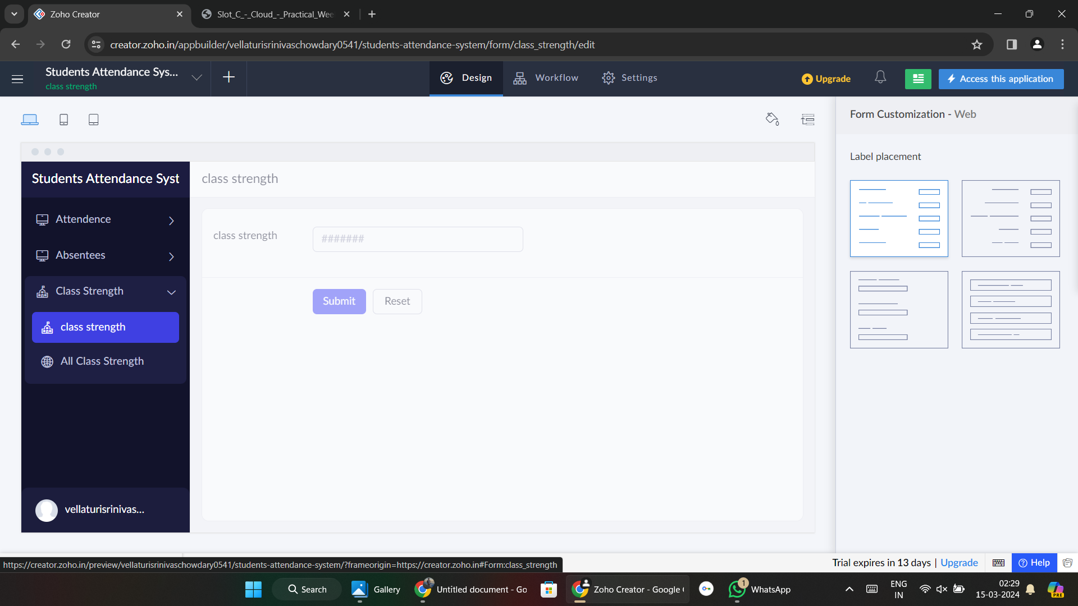

**Step 4:**  Add details.

